MGT 40750 – Quantitative Decision Modeling Fall 2017

**Assignment 3: Network Models  
Integer and Nonlinear Programming**

***Due Date: 10/02/2017 (Monday)***

**Name: ______________________________________________________**

There are five questions (15 total points) in this assignment. All relevant Excel files can be found on Sakai. Solve these questions in Excel and fill in the solution template provided below.

**Question 1: Problem 43 on page 268 in the PMS 5th Ed textbook.**

A truck must travel from New York to Los Angeles. As shown in the following Figure 1, several routes are available. The number associated with each arc is the number of gallon of fuel required by the truck to traverse the arc. Determine the route from New York to Los Angeles that uses the minimum amount of gas.

|  |
| --- |
| 800  400  950  1800  1100  600  900  600  1200  1000  900  400  1300  600 |

**Figure 1**

Step 1: Specify the Excel file Question1.xlsx. Make sure to record *all the necessary formulas*.

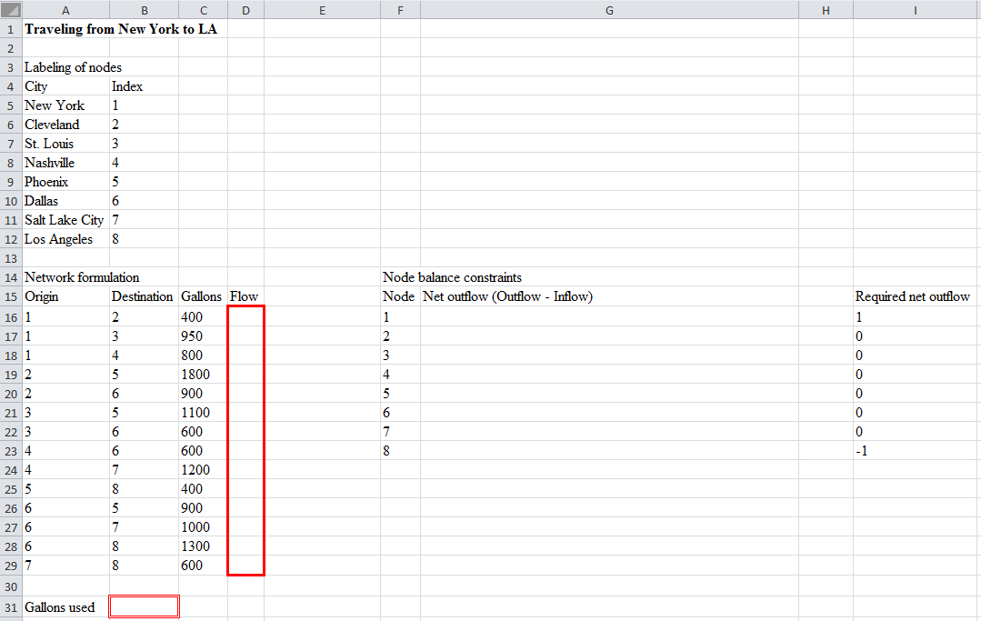

Step 2: Specify Solver

Set Objective: _________

To: ○ Max ○ Min ○ Value of: _________

By Changing Variable Cells: ______________________________________________________

Subject to the Constraints:

|  |
| --- |
|  |

□ Make Unconstrained Variables Non-Negative

Select a Solving Method: Simplex LP

*Step 3: Report your results below.*

The best route is ________________________________________________________________.

**Question 2: Problem 49 on page 269 in the PMS 5th Ed textbook.**

Touche Young has eight auditors. Each can work up to 160 hours during the next month, during which time six projects must be completed. The hours required for each project and the amounts each auditor can be billed for each project are given in the file P05_49.xlsx. Note that more than one auditor can work on a given project, in which case their hours add to the total for the project. Determine how to maximize total billings during the next month.

Step 1: Specify the Excel file Question2.xlsx. Make sure to record *all the necessary formulas*.

*Hint: Hours Spent cannot go beyond Hours Required.*

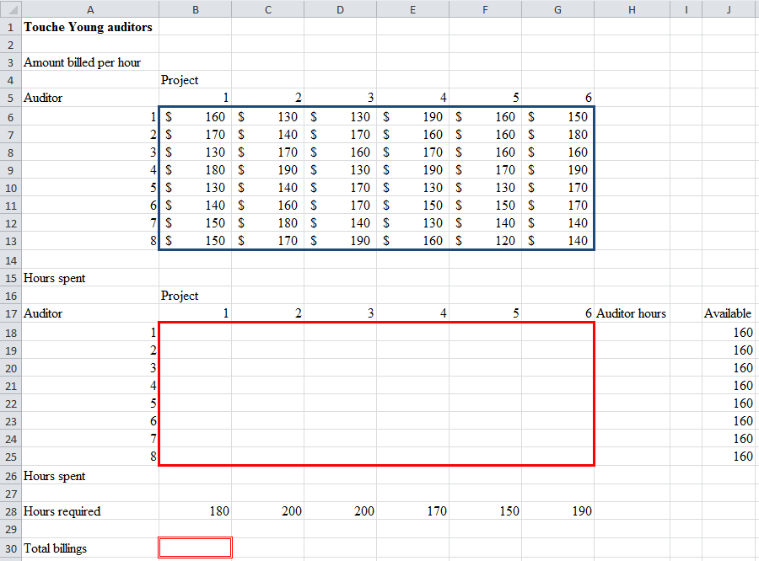

Step 2: Specify Solver

Set Objective: _________

To: ○ Max ○ Min ○ Value of: _________

By Changing Variable Cells: ______________________________________________________

Subject to the Constraints:

|  |
| --- |
|  |

□ Make Unconstrained Variables Non-Negative

Select a Solving Method: Simplex LP

Step 3: Report your results below.

The maximal total billings = ____________.

**Question 3: Problem 43 on page 328 in the PMS 5th Ed textbook.**

Coach Night is trying to choose the starting lineup for the basketball team. The team consists of seven players who have been rated on a scale of 1 (poor) to 3 (excellent) according to their ball handling, shooting, rebounding, and defensive abilities. The positions that each player is allowed to play and the players’ abilities are listed in the file P06_43.xlsx. The five-player starting lineup must satisfy the following restrictions:

* At least four members must be able to play guard (G), at least two members must be able to play forward (F), and at least one member must be able to play center (C).
* The average ballhandling, shooting, and rebounding level of the starting lineup must each be at least 1.8.
* Either player 2 or player 3 (or both) must start. Given these constraints, Coach Night wants to maximize the total defensive ability of the starting team. Use Solver to determine his starting team.

Step 1: Specify the Excel file Question3.xlsx. Make sure to record *all the necessary formulas*.

|  |
| --- |
|  |

Step 2: Specify Solver

Set Objective: _________

To: ○ Max ○ Min ○ Value of: _________

By Changing Variable Cells: ______________________________________________________

Subject to the Constraints:

|  |
| --- |
|  |

□ Make Unconstrained Variables Non-Negative

Select a Solving Method: ____________

Step 3: Report your results below.

The optimal total defensive ability of the starting team = ____________.

**Question 4: Problem 70 on page 331 in the PMS 5th Ed textbook.**

Based on Zangwill (1992). Murray Manufacturing runs a day shift and a night shift. Regardless of the number of units produced, the only production cost during a shift is a setup cost. It costs $8,000 to run the day shift and $4,500 to run the night shift. Demand for the next two days is as follows: day 1, 2000; night 1, 3000; day 2, 2000; night 2, 3000. It costs $1 per unit to hold a unit in inventory for shift.

1. Determine a production schedule that minimizes the sum of setup and inventory costs. All demand must be met on time. (*Note:* Not all shifts have to be run)
2. After listening to a seminar on the virtues of the Japanese theory of production, Murray has cut the setup cost of its day shift to $1,000 per shift and the setup cost of its night shift to $3,500 per shift. Now determine a production schedule that minimizes the sum of setup and inventory costs. All demand must be met on time. Show that the decrease in setup costs has actually raised the average inventory level. Is this reasonable?

*Hints:*

* *Suppose the capacity of each shift is 10,000. Then the effective capacity of each shift is either 10,000 if the shift is run, or 0 if the shift is not run.*
* *Use B13:E13,B15:E15 as decision variables.*

**Part a.**

Step 1: Specify the Excel file Question4.xlsx. Make sure to record *all the necessary formulas*.

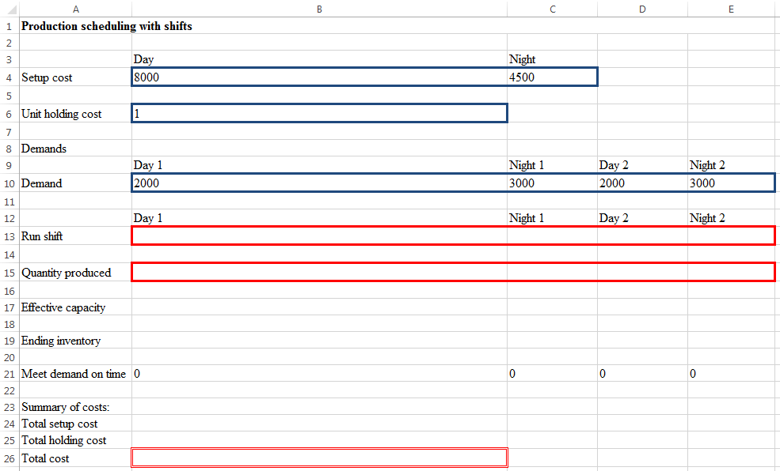

Step 2: Specify Solver

Set Objective: _________

To: ○ Max ○ Min ○ Value of: _________

By Changing Variable Cells: ______________________________________________________

Subject to the Constraints:

|  |
| --- |
|  |

□ Make Unconstrained Variables Non-Negative

Select a Solving Method: ____________

Step 3: Report your results below.

Optimal production schedule:

|  |  |  |  |  |
| --- | --- | --- | --- | --- |
|  | Day 1 | Night 1 | Day 2 | Night 2 |
| Run shift |  |  |  |  |
| Quantity produced |  |  |  |  |

The optimal total cost = ____________.

**Part b. Report your updated results below.**

Optimal production schedule:

|  |  |  |  |  |
| --- | --- | --- | --- | --- |
|  | Day 1 | Night 1 | Day 2 | Night 2 |
| Run shift |  |  |  |  |
| Quantity produced |  |  |  |  |

The optimal total cost = ____________.

Is it reasonable that the decrease in setup costs has actually raised the average inventory level? Explain.

______________________________________________________________________________________________________________________________________________________________________________________________________________________________________________________________________________________________________________________________________________________________________________________________________

**Question 5: Problem 62 on page 403 in the PMS 5th Ed textbook (just do part a).**

Monroe County is trying to determine where to place the county fire station. The locations of the county’s four major towns are as follows: (10, 20), (60, 20), (40, 30), (80, 60) (See Figure 7.50).

|  |
| --- |
| Town 1  (10, 20)  Town 3  (40, 30)  Town 2  (60, 20)  Town 4  (80, 60) |
| **Figure 2:** Existing Locations for the Fire Station |

Town 1averages 20 fires per year; town 2, 30 fires; town 3, 40 fires; and town 4, 25 fires. The county wants to build the fire station in a location that minimizes the average distance that a fire engine must travel to respond to a fire. Because most roads run in either an east-west or a north-south direction, the fire engine must do the same. For example, if the fire station is located at (30,40) and a fire occurs at town 4, the fire engine has to travel │80 - 30│ +│60 – 40│ = 70 miles to the fire.

1. Determine where the fire station should be located.

Step 1: Specify the Excel file Question5.xlsx. Make sure to record *all the necessary formulas*.

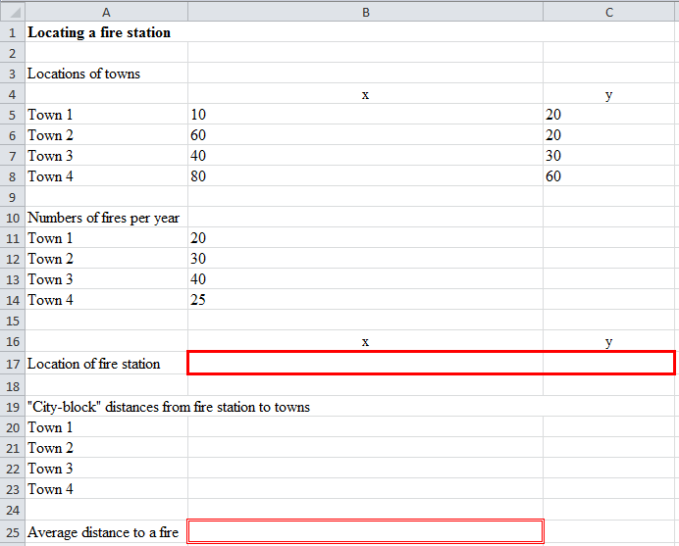

Step 2: Specify Solver

Set Objective: _________

To: ○ Max ○ Min ○ Value of: _________

By Changing Variable Cells: ______________________________________________________

Subject to the Constraints:

|  |
| --- |
|  |

□ Make Unconstrained Variables Non-Negative

Select a Solving Method: ____________

Step 3: Report your results below.

|  |  |  |
| --- | --- | --- |
|  | *x* | *y* |
| Location of fire station |  |  |

The optimal average distance to a fire = ____________.